Task 2– Feature Engineering, Model Optimization & Performance Comparison
AI & Machine Learning
Submitted By: Pranav Patil
Project Title: Feature Engineering, Model Optimization & Performance Comparison
Dataset: California Housing Dataset
Models Used: Linear Regression, Ridge Regression, Decision Tree Regressor
Tools Used: Python, Jupyter Notebook, Pandas, NumPy, Matplotlib, Scikit-learn, Joblib

Objective
The objective of this task was to apply feature engineering techniques, train multiple machine learning models, compare their performance, and identify the best-performing model using the California Housing Dataset.

Dataset Description
The California Housing Dataset provided by Scikit-Learn was used for this task. The dataset contains information about housing districts in California, including features such as:
- Median Income
- House Age
- Average Rooms
- Average Bedrooms
- Population
- Average Occupancy
- Latitude
- Longitude
The target variable is the median house value.

Methodology
1. Data Loading
The California Housing Dataset was loaded using Scikit-Learn and converted into a Pandas DataFrame for analysis.
2. Feature Scaling
Feature scaling was performed using StandardScaler. This process standardizes numerical features and improves model performance by ensuring all features contribute equally during training.
3. Data Splitting
The dataset was divided into training and testing sets using an 80:20 ratio.
4. Model Training
Three machine learning regression models were trained and evaluated:
- Linear Regression
- Ridge Regression
- Decision Tree Regressor
5. Model Evaluation
The models were evaluated using:
- RMSE (Root Mean Squared Error)
- R² Score (Coefficient of Determination)

Results
Model Performance Comparison
Model | RMSE | R² Score
Linear Regression | 0.745581 | 0.575788
Ridge Regression | 0.745554 | 0.575819
Decision Tree Regressor | 0.724234 | 0.599732

Best Performing Model
Based on the evaluation metrics, the Decision Tree Regressor achieved the best overall performance.
RMSE: 0.724234
R² Score: 0.599732
The model produced the lowest prediction error and the highest explanatory power among all tested models.

Visualization
Actual vs Predicted House Prices
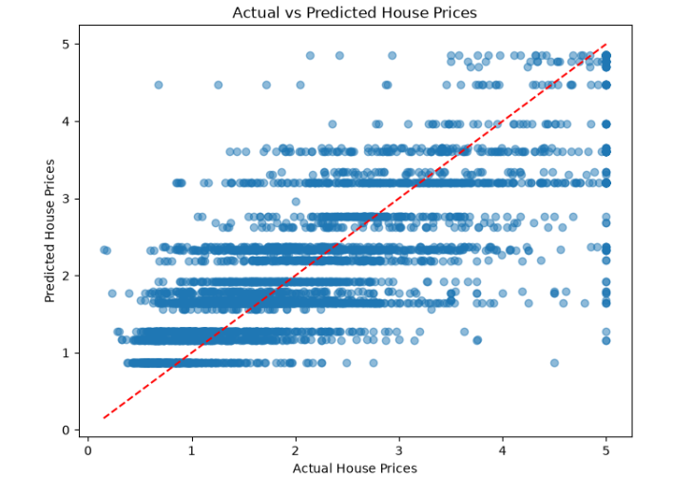
The scatter plot compares actual house prices with model predictions. Points closer to the diagonal reference line indicate more accurate predictions.

Model Saving
The best-performing model was successfully saved using Joblib.
File Generated:
best_model.pkl
This allows the trained model to be reused without retraining.
Key Learnings
- Data preprocessing and feature scaling techniques
- Implementation of multiple regression models
- Performance comparison using RMSE and R² Score
- Visualization of prediction results
- Model persistence using Joblib
- Practical machine learning workflow using Scikit-Learn

Conclusion
The California Housing Dataset was successfully analysed using machine learning techniques. Feature scaling improved data preparation, and multiple regression models were compared to identify the best-performing algorithm. The Decision Tree Regressor achieved the highest R² Score and the lowest RMSE, making it the most suitable model among the tested approaches. This task provided valuable hands-on experience in machine learning model development, evaluation, optimization, and deployment preparation.

Submitted By
Shruti Vijaykumar Patil
Internship
Artificial Intelligence & Machine Learning Internship
Organization
Maincrafts Technology

